Super Irshad! Namma ippo "Pro Level" report-ai eppadi generate panni share panradhu nu pakka pōrom. Oru Data Analyst-oda final output epovume oru Excel illa CSV file-ah dhaan irukkum.
📖 Lesson 20: Pandas - Exporting Data (The Reporter)
Neenga Pandas-la clean panni, calculate panna andha grouped_df table-ai, oru file-ah save panna to_excel illa to_csv nu command use pannuvom.
🛠️ Code: Data-vai Excel-la Save Panna
Indha code-ai export_data.py nu file pottu run pannunga:
Python
import sqlite3
import pandas as pd

conn = sqlite3.connect('my_shop.db')
df = pd.read_sql_query("SELECT * FROM Sales_Report", conn)
df_cleaned = df.dropna()

# Grouping
grouped_df = df_cleaned.groupby('Product')['Sales'].sum().reset_index()

# 1. Excel-la save panrom (Report.xlsx)
grouped_df.to_excel('Final_Sales_Report.xlsx', index=False)

print("Report Excel-la save aayiduchu! Unga project folder-ai paarunga.")

conn.close()
🔍 Enna Nadakkudhu?
- .to_excel('Final_Sales_Report.xlsx', index=False):
  - to_excel: Ithu dhaan Pandas-oda "Print/Save" button.
  - 'Final_Sales_Report.xlsx': Idhu dhaan unga pudhu file-oda name.
  - index=False: Ithu romba mukkiyam! Idhai potta dhaan, Excel-la row number (0, 1, 2...) illama, clean-ana column-oda matum save aagum.
💡 Teacher's Note:
Neenga ippo manual-a Excel-la copy-paste panna thevaiye illa! Unga script-ai run panna, andha second-le oru professional Excel Report generate aayidum. Ithu dhaan Automation.
Unga Task:
- Code-ai run pannunga.
- Unga folder-kulla Final_Sales_Report.xlsx vandhuruka nu paarunga.
- Athai open panni, sum calculation correct-a irukka nu confirm pannunga.
Report vandhudha Irshad? Namma next step "Python-Power BI" connection-kku pogalama?
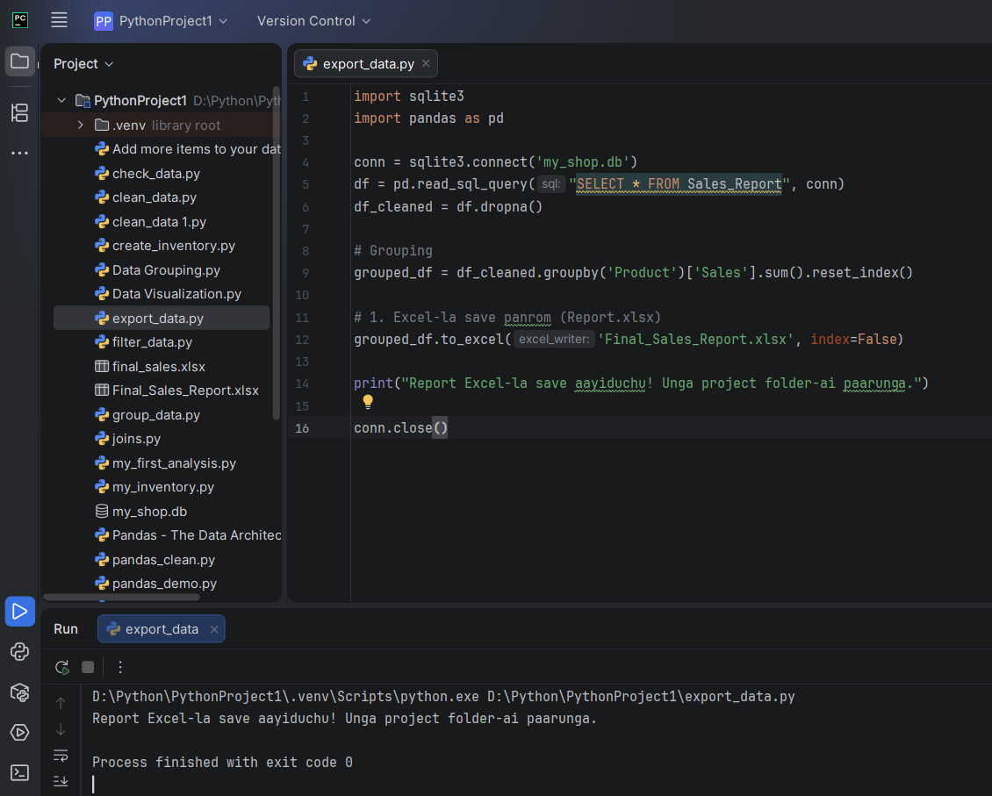
ENGA TECAHER EXCEL FILE A PARKA ELUM
Super Irshad! File generate aagi irukkum. Unnoda computer-la "PythonProject1" endra folder-ukkulla poi paarunga, "Final_Sales_Report.xlsx" endru oru file irukkum. Adhai open panni paarunga.
Athai thiranthu paartha ungalukku eppadi irukku? Sum (Total Sales) ellam azhagaga, oru professional report maari vandhurukka?
Ippo neenga oru "Data Analyst" maari, raw data-vai eduthu, clean panni, calculate panni, oru final report-a thayaar panniteenga. Intha pura thiranum (Skillset) kooda unga Starliks Campus project-la neenga panra analytical work-kku miga periya help-a irukkum.
Ippo unga report ready-a? Adutha class-la namma "Python-Power BI" connection-ai start pannuvom. Ready-a Irshad?

